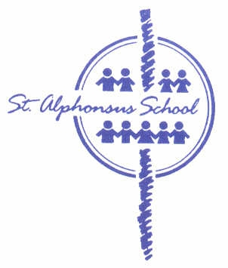
St. Alphonsus School
Report Card 2018-19

Student: | Grade: 2
MET #: | Teacher: Mr. Allan Sharman

Program(√): _√_ Regular
___ Student Support Plan
___ Adapted:
___ Individualized:

Performance Scale
4 | 3 | 2 | 1 | ND
Very good to excellent understanding and application of concepts and skills | Good understanding and application of concepts and skills | Basic understanding and application of concepts and skills | Limited understanding and application of concepts and skills; see teacher comments | Does Not yet Demonstrate the required understanding and application of concepts and skills; see teacher comments
Additional Codes:
NA-Not applicable this term
IN- Incomplete-Not enough evidence to determine a grade at this time

Learning Behaviour Scale
M | S | O
Meets Expectations | Some Support Required | Ongoing Support Required

Attendance | Term 1  September, October | Term 2  November, December,  January, February | Term 3  March, April,  May, June
Days Absent
Lates

Religion: Our religion program is based on a spiral curriculum that integrates the fundamental themes of the Catechism of the Catholic Church with Scripture and Catholic Social Teachings. In grade two, students learn about Reconciliation and Eucharist, with a thematic focus on Jesus as the True Vine.

ENGLISH LANGUAGE ARTS |  | Term 1 | Term 2 | Term 3
Comprehension | Reading
 | Listening and Viewing
Communication | Writing
 | Speaking and Representing
ELA COMMENTS
Term 1:

Term 2:

Term 3:

MATHEMATICS | Term 1 | Term 2 | Term 3
Number Concepts
Patterns and Relations
Shape and Space
Statistics and Probability
MATHEMATICS COMMENTS

Term 1:

Term 2:

Term 3:

SCIENCE | Term 1 | Term 2 | Term 3
Knowledge and Understanding
Scientific Inquiry Process
Design process/problem solving

SOCIAL STUDIES | Term 1 | Term 2 | Term 3
Knowledge and Understanding
Research and Communication
Critical thinking and Citizenship

HEALTH | Term 1 | Term 2 | Term 3
Knowledge and Understanding

VISUAL ARTS | Term 1 | Term 2 | Term 3
Understanding and Creative Application

MUSIC – Mr. John Cox | Term 1 | Term 2 | Term 3
Skills and Concepts
Participation

FRENCH – Mme Kristen Curwain | Term 1 | Term 2 | Term 3
Comprehension
Communication
Participation

PHYSICAL EDUCATION – Mr. Blake McInnis | Term 1 | Term 2 | Term 3
Skill Development
Sportspersonship

LEARNING BEHAVIOURS | Term 1 | Term 2 | Term 3
Personal Management Skills
Works independently, Completes assignments, Organization
Active Participation in Learning
Participates in discussions/activities, Sets goals
Social Responsibility
Uses technology responsibly, Works cooperatively, Resolves conflicts

GENERAL COMMENTS
Term 1:
Term 2:
Term 3:

