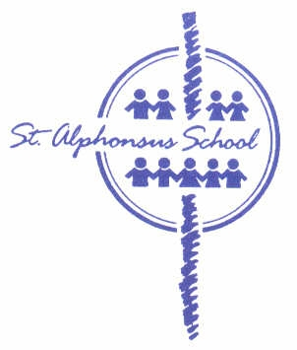
St. Alphonsus School
Report Card 2018-19

Student: | Grade: 5
MET #: | Teacher: Mrs. Jennifer Pieczonka

Program(√): _√_ Regular
___ Student Support Plan
___ Adapted:
___ Individualized:

Performance Scale
4 | 3 | 2 | 1 | ND
Very good to excellent understanding and application of concepts and skills | Good understanding and application of concepts and skills | Basic understanding and application of concepts and skills | Limited understanding and application of concepts and skills; see teacher comments | Does Not yet Demonstrate the required understanding and application of concepts and skills; see teacher comments
Additional Codes:
NA-Not applicable this term
IN- Incomplete-Not enough evidence to determine a grade at this time

Learning Behaviour Scale
M | S | O
Meets Expectations | Some Support Required | Ongoing Support Required

Attendance | Term 1  September, October | Term 2  November, December,  January, February | Term 3  March, April,  May, June
Days Absent
Lates

Religion: Our religion program is based on a spiral curriculum that integrates the fundamental themes of the Catechism of the Catholic Church with Scripture and Catholic Social Teachings. In grade five, students deepen their understanding of the Sacraments and our worship traditions through the theme the Bread of Life.

ENGLISH LANGUAGE ARTS |  | Term 1 | Term 2 | Term 3
Comprehension | Reading
 | Listening and Viewing
Communication | Writing
 | Speaking and Representing
ELA COMMENTS
Term 1:

Term 2:

Term 3:

MATHEMATICS | Term 1 | Term 2 | Term 3
Number Concepts
Patterns and Relations
Shape and Space
Statistics and Probability
MATHEMATICS COMMENTS

Term 1:

Term 2:

Term 3:

SCIENCE | Term 1 | Term 2 | Term 3
Knowledge and Understanding
Scientific Inquiry Process
Design process/problem solving

SOCIAL STUDIES | Term 1 | Term 2 | Term 3
Knowledge and Understanding
Research and Communication
Critical thinking and Citizenship

HEALTH | Term 1 | Term 2 | Term 3
Knowledge and Understanding

VISUAL ARTS | Term 1 | Term 2 | Term 3
Understanding and Creative Application

MUSIC – Mr. John Cox | Term 1 | Term 2 | Term 3
Skills and Concepts
Participation

FRENCH – Mme Kristen Curwain | Term 1 | Term 2 | Term 3
Listening Comprehension
Oral Communication
Reading Comprehension
Written Communication
Participation

PHYSICAL EDUCATION – Mr. Blake McInnis | Term 1 | Term 2 | Term 3
Skill Development
Sportspersonship

LEARNING BEHAVIOURS | Term 1 | Term 2 | Term 3
Personal Management Skills
Works independently, Completes assignments, Organization
Active Participation in Learning
Participates in discussions/activities, Sets goals
Social Responsibility
Uses technology responsibly, Works cooperatively, Resolves conflicts

GENERAL COMMENTS
Term 1:
Term 2:
Term 3:

